**OVERVIEW OF CRIME TREND IN WEST AFRICA FROM THE YEAR 1973 – 2020**

Report Prepared by: Bello Bolaji Alabi

Date Prepared: 9th December, 2024

**Student ID:** VEPH/20A/DA071

Introduction

This report provides an in-depth analysis of crime trends in West Africa between 1974 and 2020, highlighting a marked increase in fatalities and injuries related to crime, with Nigeria bearing the brunt of the impact. Key actors, such as Boko Haram, emphasize the urgent need for coordinated regional counter-terrorism measures. The insights derived from this analysis aim to inform policy development, optimize resource distribution, and shape strategic actions to enhance security and promote stability across the region.

Methodology: The Dataset was gotten from Kaggle, Data Cleaning, Data Preparation and Analysis all was done with excel also with the Visualization.

**1 Crime Rate Trends Over Time**

* **Historical Overview**: Crime rates were relatively insignificant in the 1900s. A slight increase was observed in 2010 (70 incidents).
* **Peak Activity**: Crime rates surged significantly, peaking in 2018 with a record 919 cases.
* **Recent Decline**: Following the peak, crime rates declined to 720 in 2019 and further to 684 in 2020.

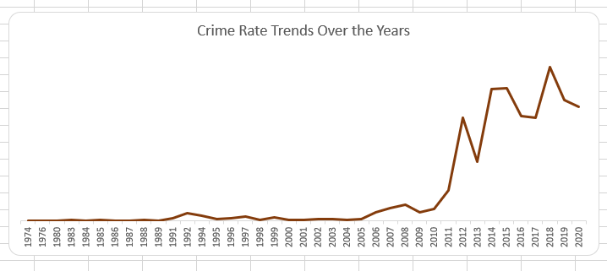

2 **Countries with the Most Cases**

* **Major Contributor**: Nigeria accounted for 81% of recorded crime cases.
* **Other Contributors**: Cameroon contributed 13%, Niger 4%, and Chad 2% of crime incidents.
* **Zero Recorded Crime**: Ghana and Benin reported no crime cases over the analyzed period.

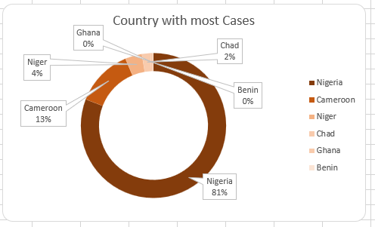

3 **Top Cities with the Most Cases**

* **Highest Incidence**: Maiduguri recorded the most cases (488), followed by Kano (130).

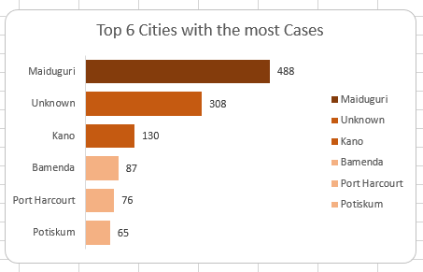

4 **Fatality and Injury Rates by Country**

* **Fatalities**:
  + Nigeria led with 29,093 fatalities.
  + Cameroon (3,186), Niger (2,284), and Chad (1,664) followed.
  + Ghana and Benin reported minimal fatalities, at 27 and 2, respectively.
* **Injuries**:
  + Nigeria recorded the most injuries (12,638).
  + Chad (1,867), Cameroon (1,642), and Niger (751) followed.
  + Ghana and Benin recorded significantly lower injury rates, at 35 and 9, respectively.

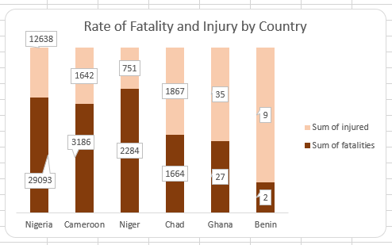

5 **Fatality and Injury Rates by City**

* **Major Impact Zones**: Maiduguri experienced the highest rates of both fatalities and injuries, followed by Kano, Konduga, Damboa, and Fotokol.

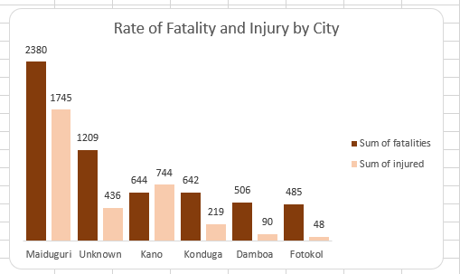

**Top Perpetrators by Attack**

* **Leading Perpetrators**:
  + Boko Haram recorded the most incidents (2,629).
  + Fulani Extremists (845) and Boko Haram Suspects (672) followed.
  + Separatists (239) and Fulani Extremists Suspects (214) were also significant actors.

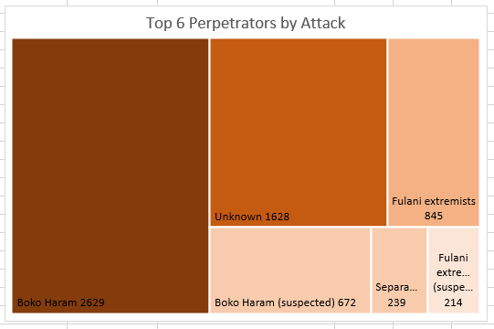

**Most Targeted Regions**

* **Primary Targets**:
  + Private Citizens and Properties were most targeted (3,047 cases).
  + Other targets included the Military (674), Government (General) (539), Police (436), Businesses (307), and Religious Figures (280).

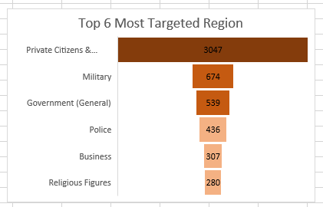

**Recommendations**

1. **Strengthen Security in High-Risk Areas**:
   * Deploy additional security resources to Maiduguri, Kano, and other affected cities to reduce incidents and casualties.
2. **Focus on Root Causes**:
   * Conduct in-depth analyses of socioeconomic factors contributing to high crime rates in Nigeria, Cameroon, and Chad.
3. **Improve Infrastructure in Low-Incidence Countries**:
   * Enhance crime reporting and prevention mechanisms in Ghana and Benin to maintain their low crime rates.
4. **Targeted Support for Victims**:
   * Establish support programs for private citizens and businesses disproportionately affected by crime.
5. **Collaborative Efforts Against Perpetrators**:
   * Strengthen international and regional collaboration to address activities of groups like Boko Haram and other extremist factions.
6. **Data-Driven Policy Making**:
   * Use predictive analytics to identify potential future hotspots and allocate resources proactively.
7. **Enhance Community Engagement**:
   * Promote community-based programs to foster trust and cooperation between local populations and law enforcement.
8. **Monitor Trends and Progress**:
   * Regularly update crime data dashboards to monitor trends, measure the effectiveness of interventions, and guide future strategies.

Conclusion

This analysis underscores the persistent challenges posed by crime and insecurity in West Africa, with Nigeria disproportionately affected by incidents, fatalities, and injuries. The insights highlight the critical need for targeted interventions in high-risk areas, proactive engagement with communities, and robust international collaboration to address the activities of extremist groups like Boko Haram. By focusing on data-driven policymaking, strengthening infrastructure, and fostering regional cooperation, stakeholders can work towards reducing crime rates, improving public safety, and ensuring stability. Continuous monitoring and adaptive strategies will be essential to address emerging challenges and achieve long-term security and development goals in the region.